**1. File Management:**

**Write a script that takes a directory path as input and creates a new directory within it named "Backups_$(date +%Y-%m-%d)".**

**Create a script that renames all files in a directory with the extension ".txt" to have a prefix of "report_".**

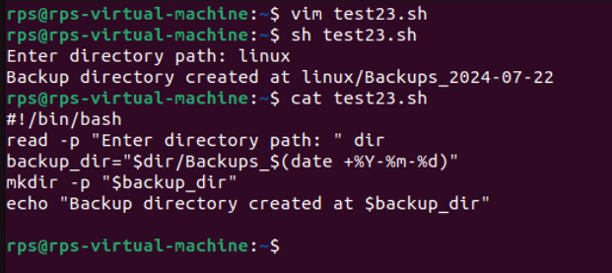

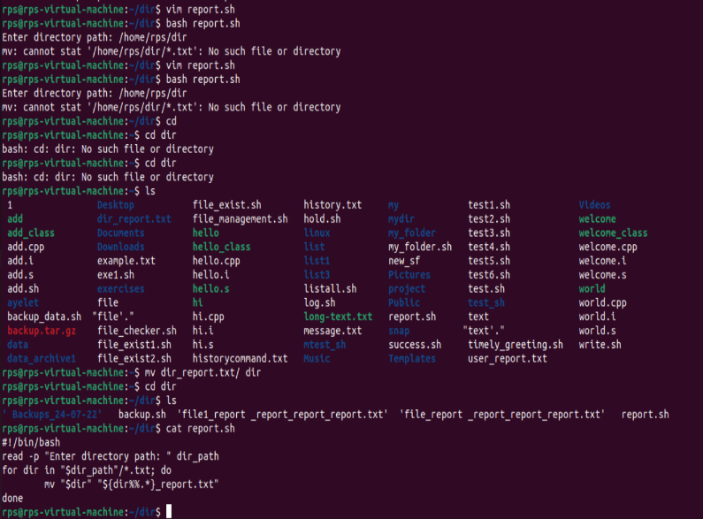

**2. User Interaction:**

**Write a script that prompts the user for their name and age, then greets them with a personalized message.**

**Design a script that displays a menu with options like "List files," "Create directory," and "Exit." Allow the user to choose an option and perform the corresponding action**

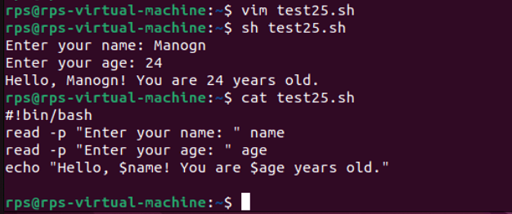

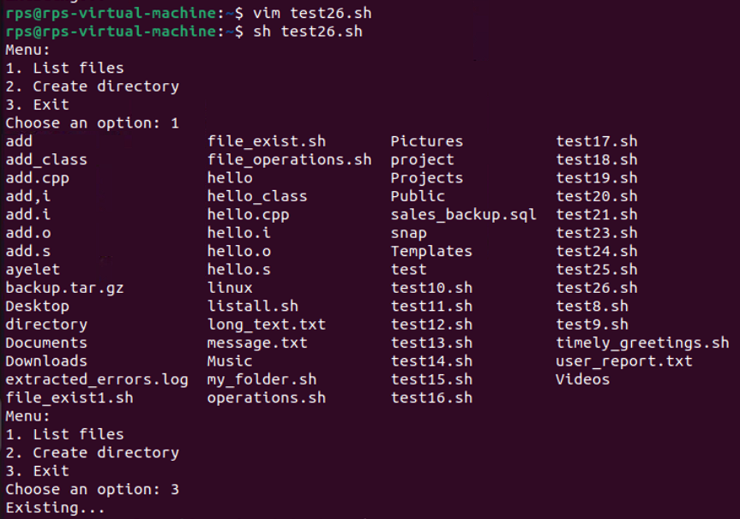

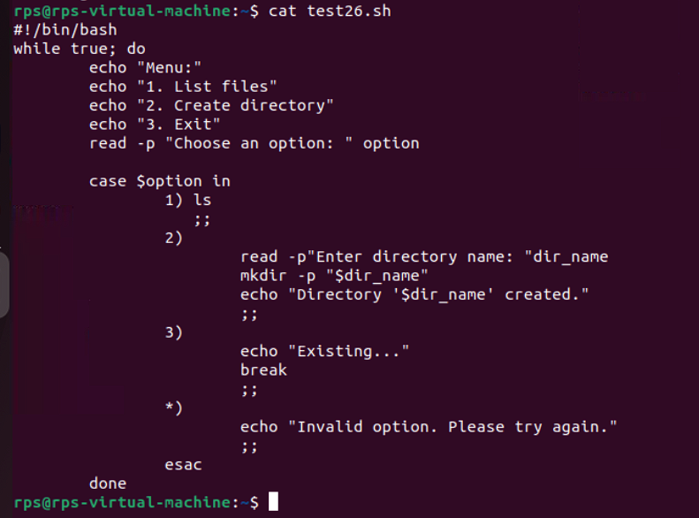

**3. Text Processing:**

**Write a script that reads the contents of a file line by line, counts the number of lines, and prints the total.**

**Create a script that takes a text file as input and replaces all occurrences of a specific word with another word.**

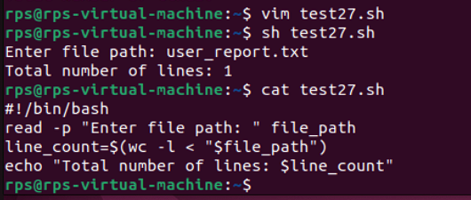

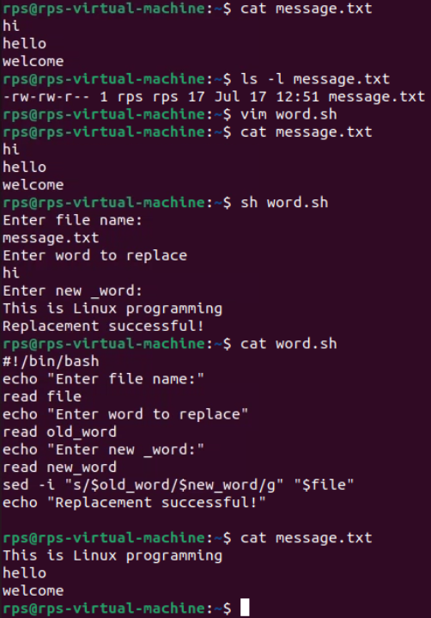

**4. System Administration:**

**Write a script that checks if a specific package is installed and, if not, installs it using the appropriate package manager (e.g., apt-get, yum).**

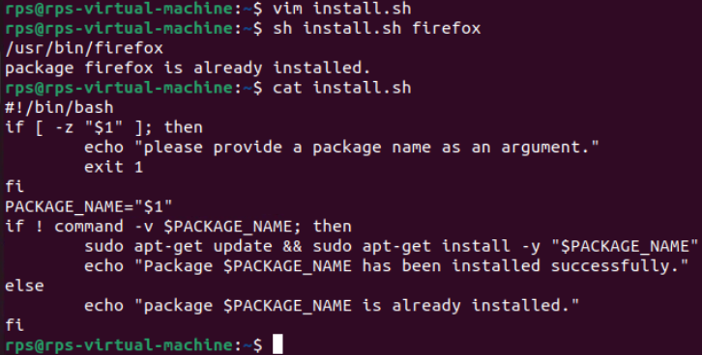

**Create a script that monitors disk usage and sends an email notification if it exceeds a certain threshold.**

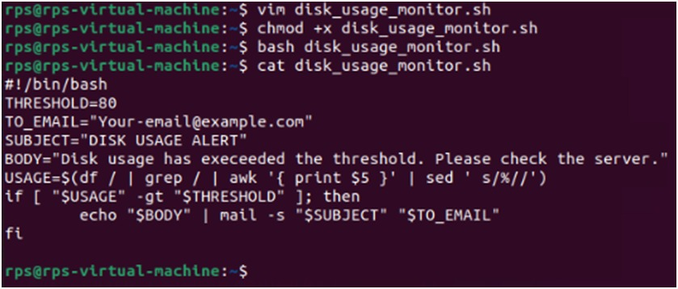

**Disk Usage Below Threshold**

**If disk usage is below the threshold, there will be no output from the script. No email will be sent.**

**5. Data Manipulation:**

**Write a script that reads a CSV file, calculates the average of a specific column, and prints the result.**

**Create a script that generates a random password of a specified length, meeting certain criteria like uppercase, lowercase, numbers, and symbols.**

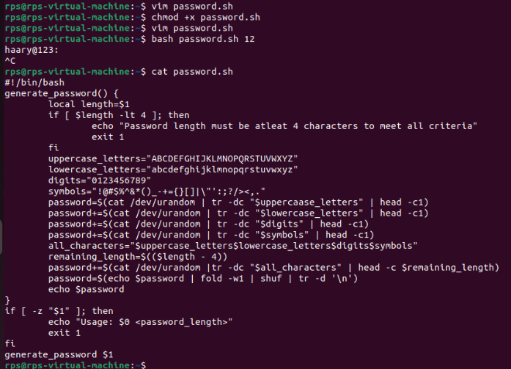

**6. Network Operations:**

**Write a script that pings a list of servers and reports if any are unreachable.**

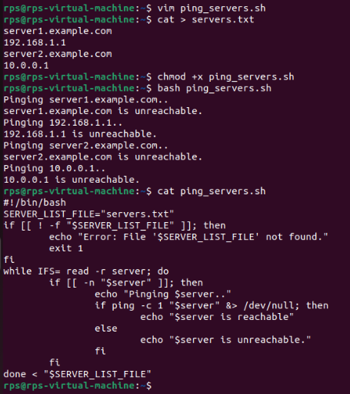

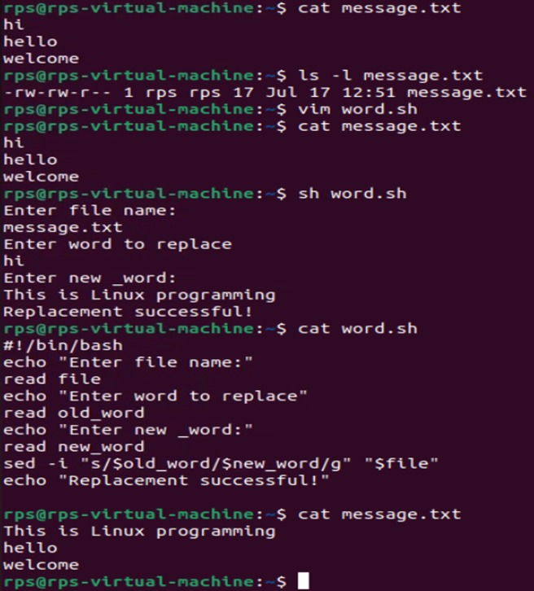

**Signal Program:**

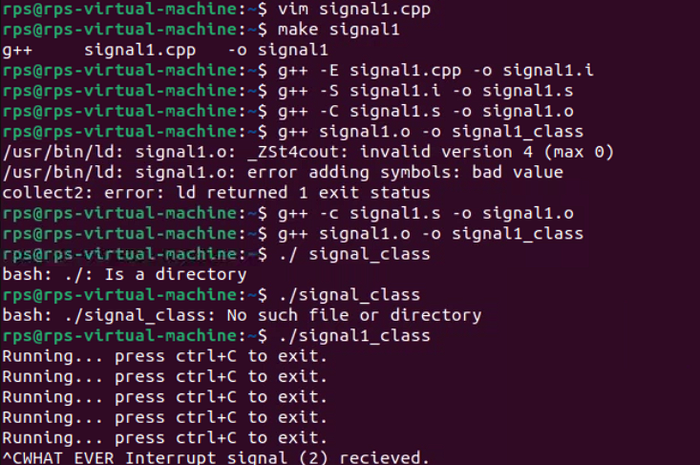

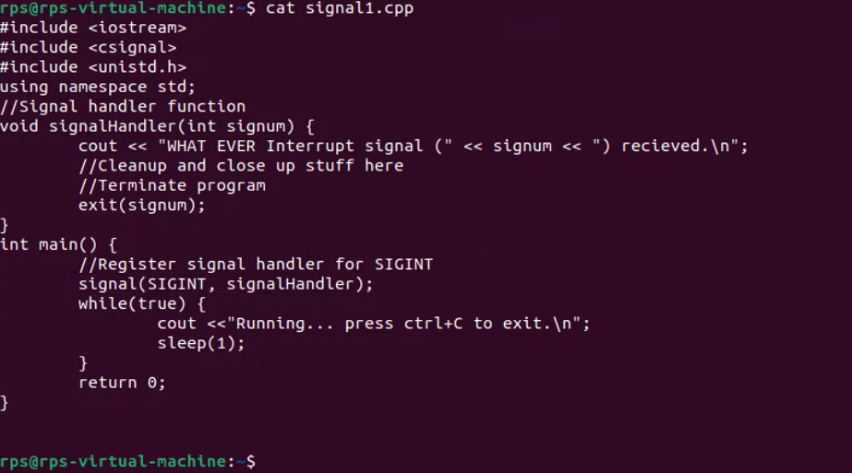

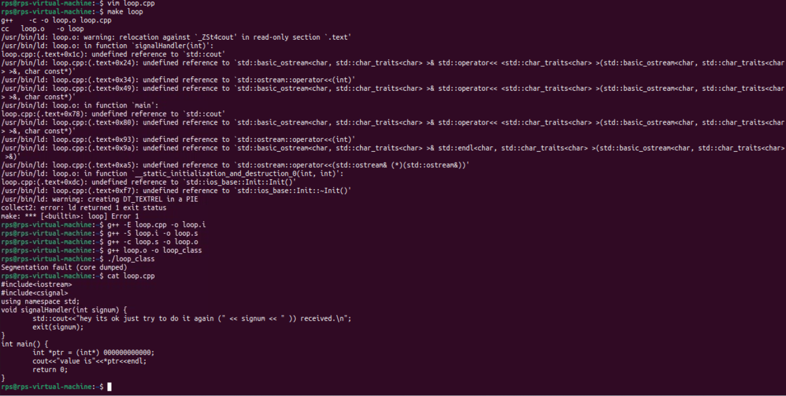

**Using kill SIGINT**

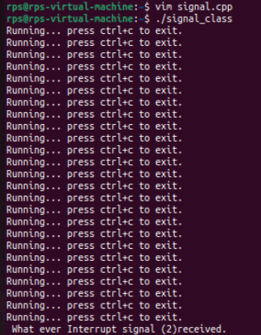

**USING KILL SIGSEGV**

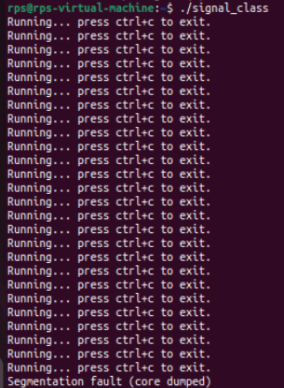

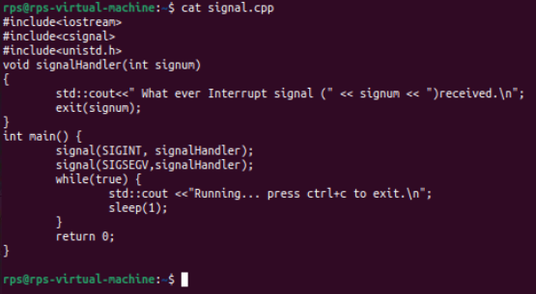

**Using ctrl+c and ctrl+z:**

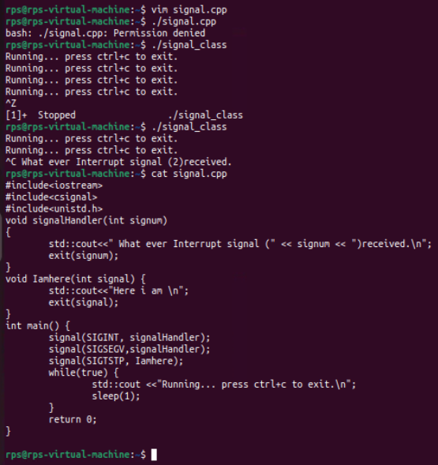

**Sigaction Program:**

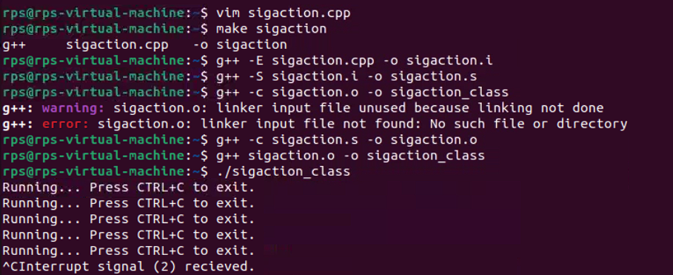

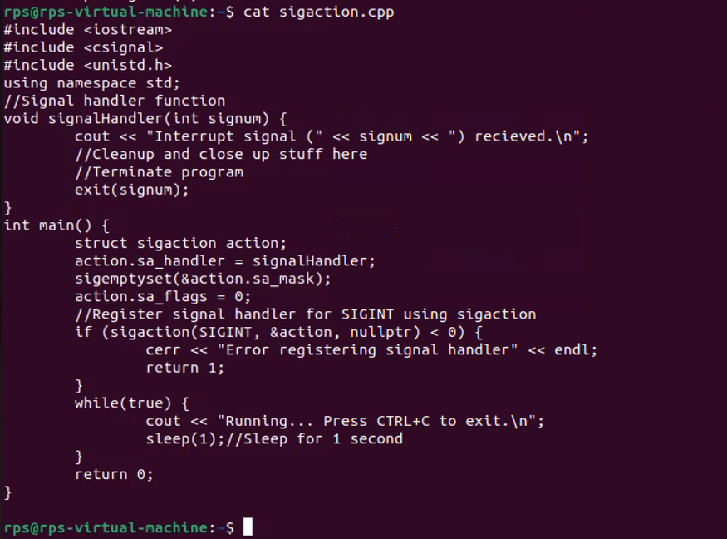

**Signum Program:**

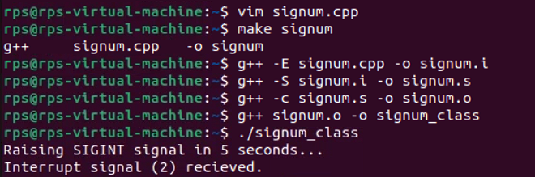

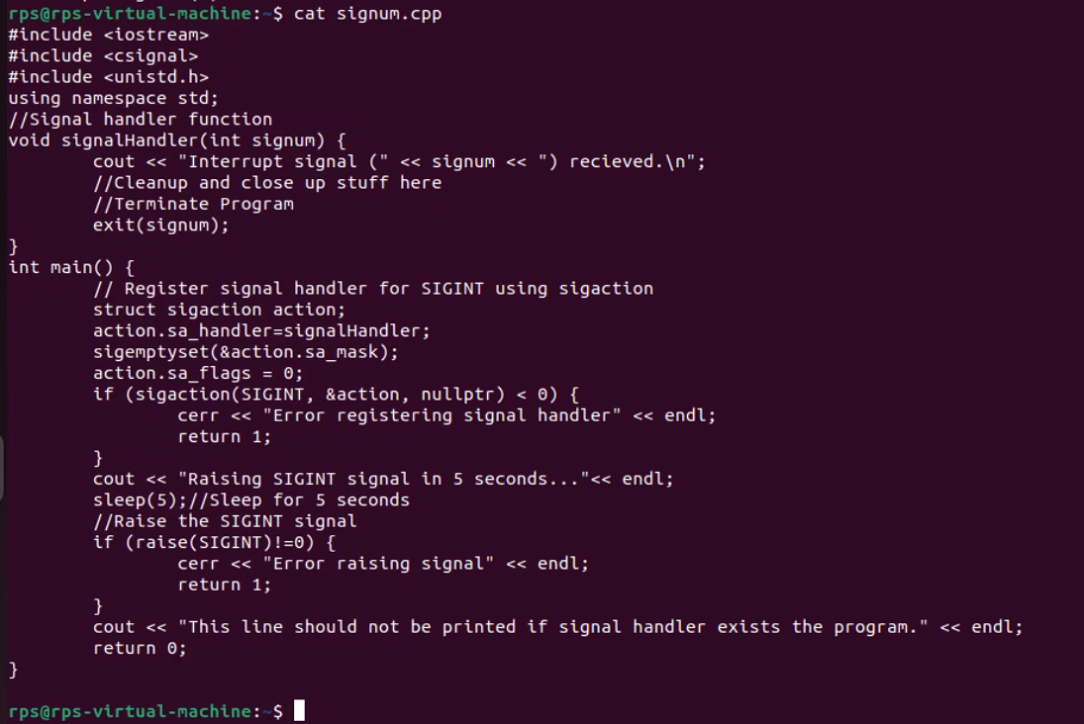

**Basic Handling vs. Advanced Control: Implement signal handling using both signal and sigaction (in separate program runs). Observe the behavior. Which API allows for more control over the signal handler? Explain the key difference in a comment within your code.**

**The key difference between signal and sigaction lies in the control they offer:**

* **signal:** This function provides a basic mechanism to handle signals. It allows you to set a simple signal handler but doesn't offer much control over the behavior of the signal handling process. It is also less portable and can exhibit different behaviors on different systems.
* **sigaction:** This function provides more advanced control over signal handling. It allows you to specify additional options (through the **sa_flags** field) and control which signals are blocked during the execution of the handler (through the **sa_mask** field). **sigaction** is more flexible and powerful compared to signal.

**Signal:**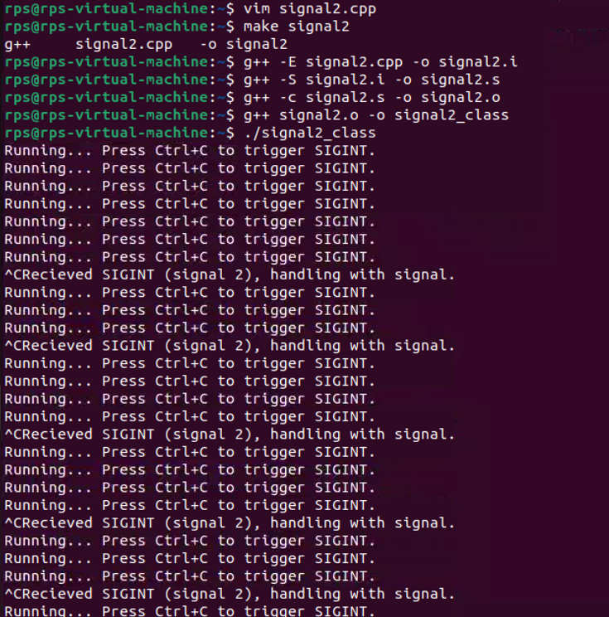

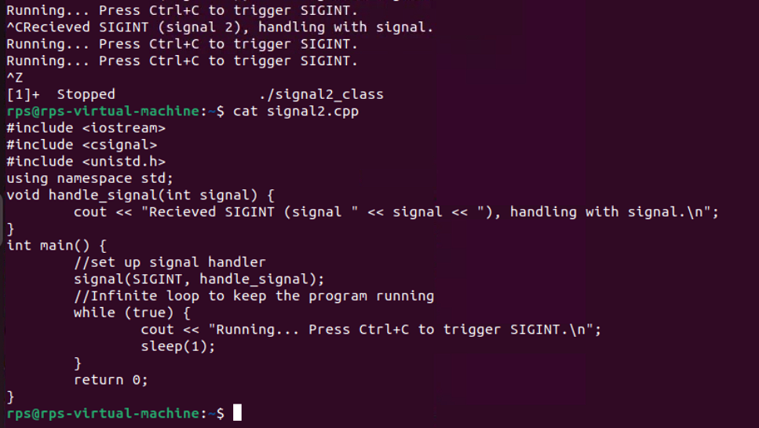

**Graceful Termination with Signal Handling**

**Objective: Modify your program to demonstrate graceful termination upon receiving a specific signal (e.g., SIGINT). Within the signal handler, perform any necessary cleanup tasks (e.g., closing files, releasing resources) before exiting the program gracefully.**

**Implementation:**

**In your signal handler function, include code to perform cleanup actions. This might involve closing open files, releasing memory, or writing data to disk.**

**Use exit(0) or similar methods to terminate the program after cleanup is complete.**

**Signal:**

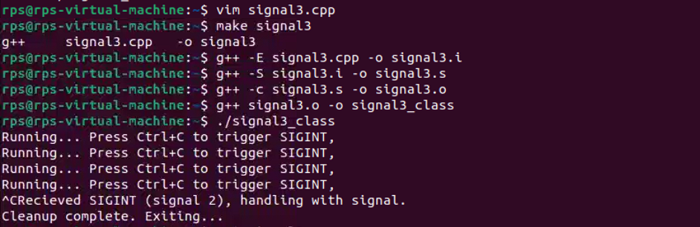

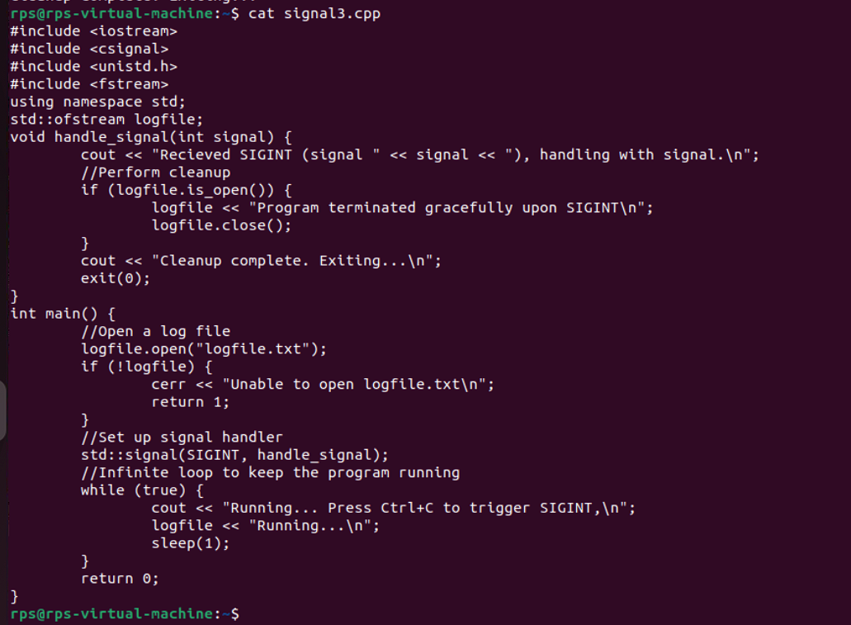

**Sigaction:**

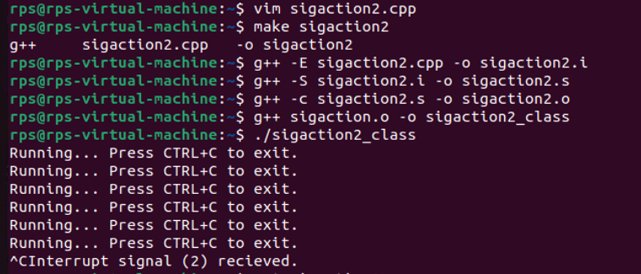

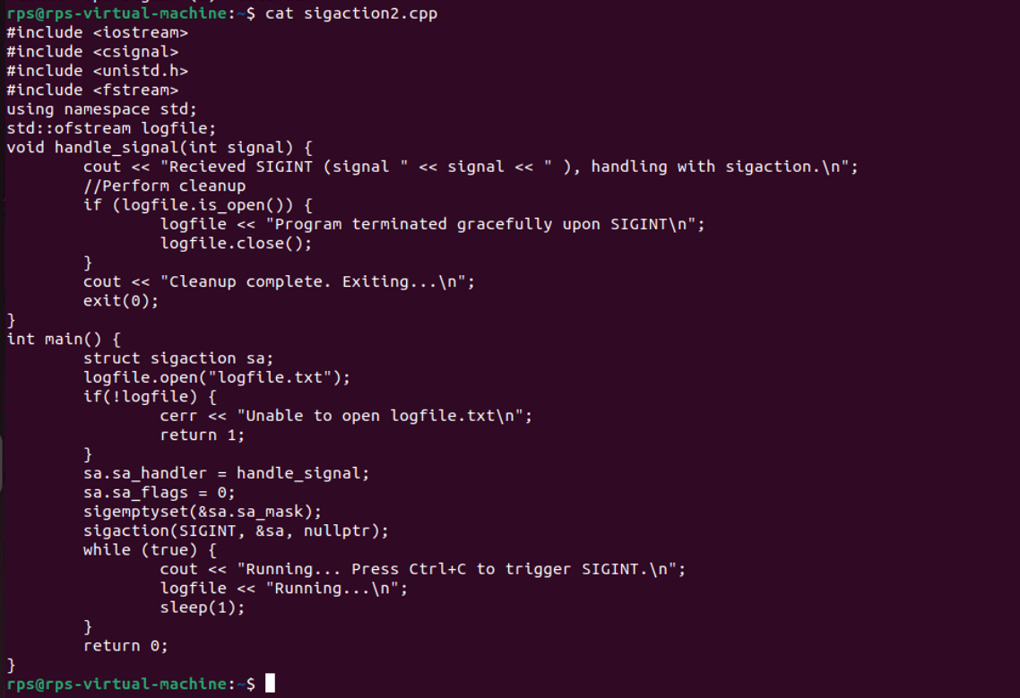

**Array:**

